Lab 4

Q1.) D – 100 gets added to the sequence number as the sequence number keeps track of the amount of bits passed through

Q2.) No – 1234 + 100 = 1334. 1335 is outside the sequence number

Q3.) 4 – Timeout is always longer than RTT but RTT may vary so it depends on deviation

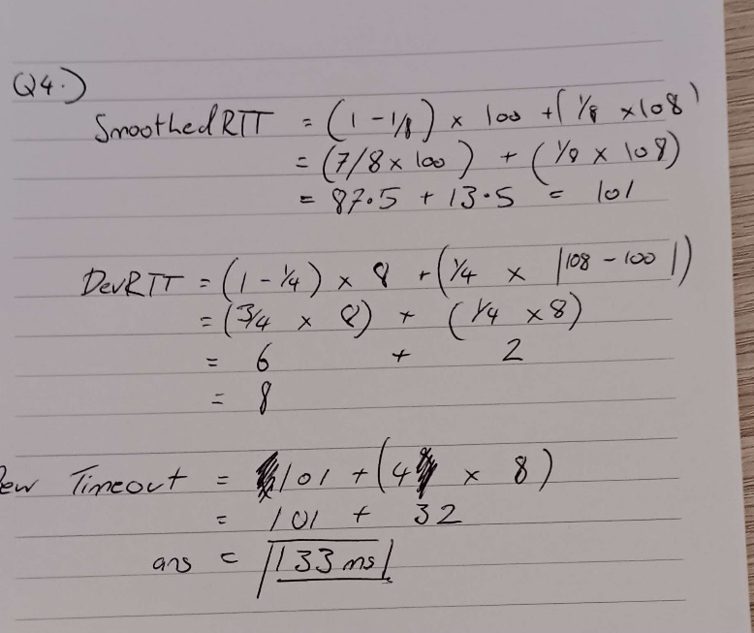Q4.)

Q5.) C – The receive window tells the sender how much bits the receive at one time

Q6.) 1.5RTT – Sender sends a SYN package then the receiver sends back a SYN ACK, then the sender sends a ACK package which takes half an RTT

Q7.) B – TCP sends 3 ACK packets back to back which makes the sender assume the next packet in the sequence has been lost and retransmits only that one

Q8.) True – If a sender underestimates the round-trip time the receiver might not receive the package on time and induce a timeout

Q9.) SMTP, HTTP, FTP

Q10.) C – 100,00 / 125,000 = 0.8

Q11.) C –

1,000  × 150  = 150,000

150,000  − 125,000  = 25,000

25,000 / 100,000  ​= 4

4 seconds

Q12.) B – 4 packets \* 100ms = 40pkts/s